Contents
A. Themes 2
B. Dashboards 4
1. Viewing the current configuration 4
2. Adding a new tab 5
3. Editing an existing tab 6
4. Adding or removing a widget 7
C. Portal Parameters (Admin settings) 7
D. Interview Panel settings 8
E. HR Admin (widget) Settings 9
F. Language Pack 10
G. Template configuration 12
1. Document templates 12
2. Document types 13
H. Reference data 13
1. Event Management 14
I. Online application form profile and templates 16
J. Related Documents 17

Version | Date updated | Updated By | Explanation
1.0 |  | HC | Created following the implementation of V26
2.0 | 14 Oct 20 | HC | Updated following the implementation of V28 and the introduction of HR Admin in the web

Other documents:

CDD for the Language Pack
CDD for the Administrator Dashboard
CDD for the People Management Dashboard
CDD to the Recruitment Dashboard
CDD for the Employee and Manager Portals
CDD for the infrastructure (Theme, Portal Settings, Back Office Settings)
All of the CDDs can be found here: CDDs

Configuration guides

Themes

Core|Portal > Administrator Dashboard > Admin Tools > Themes

The current theme is created from the Core Blue theme.

Click on the ellipses and choose ‘New From’. | 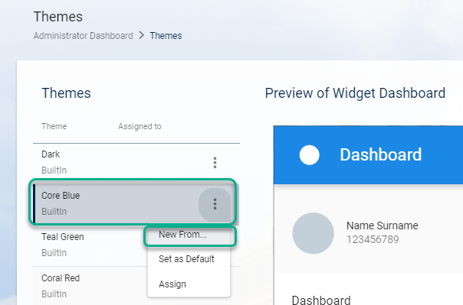

- Click on ‘Widget Dashboard’ from the options on the right

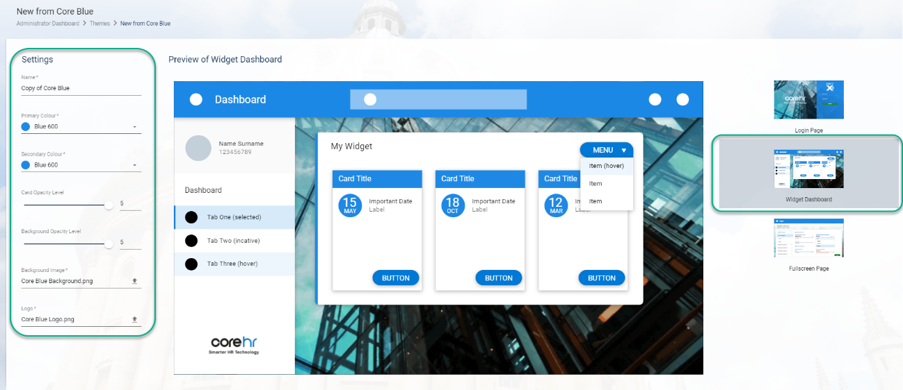

- Enter the settings as follows:
Field | Setting
Name* | University of Oxford
Colour scheme Primary colour* | Hex #002147 (Red: 0, Green: 33, Blue: 71)
Colour scheme Secondary colour* | Hex #002147 (Red: 0, Green: 33, Blue: 71)
Card Opacity level | 3
Background Opacity level | 3
Background Image* | RC5 – final (jpg)  Less than 10MB, resolution under 4,000px width * 2,500px height
Logo* | Dark Login Logo.png  Less than 1 MB, resolution under 600px width * 300px height.
- Click on the ellipses against your new theme and choose Assign |  | 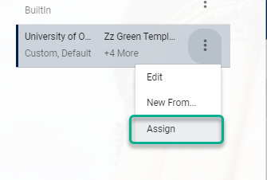
- Choose University of Oxford from the drop-down list and click OK. |  | 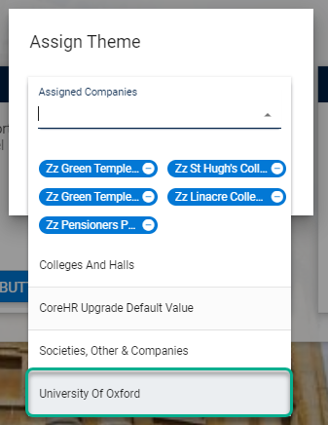

- A confirmation message will appear.

- Check the preview is as expected.

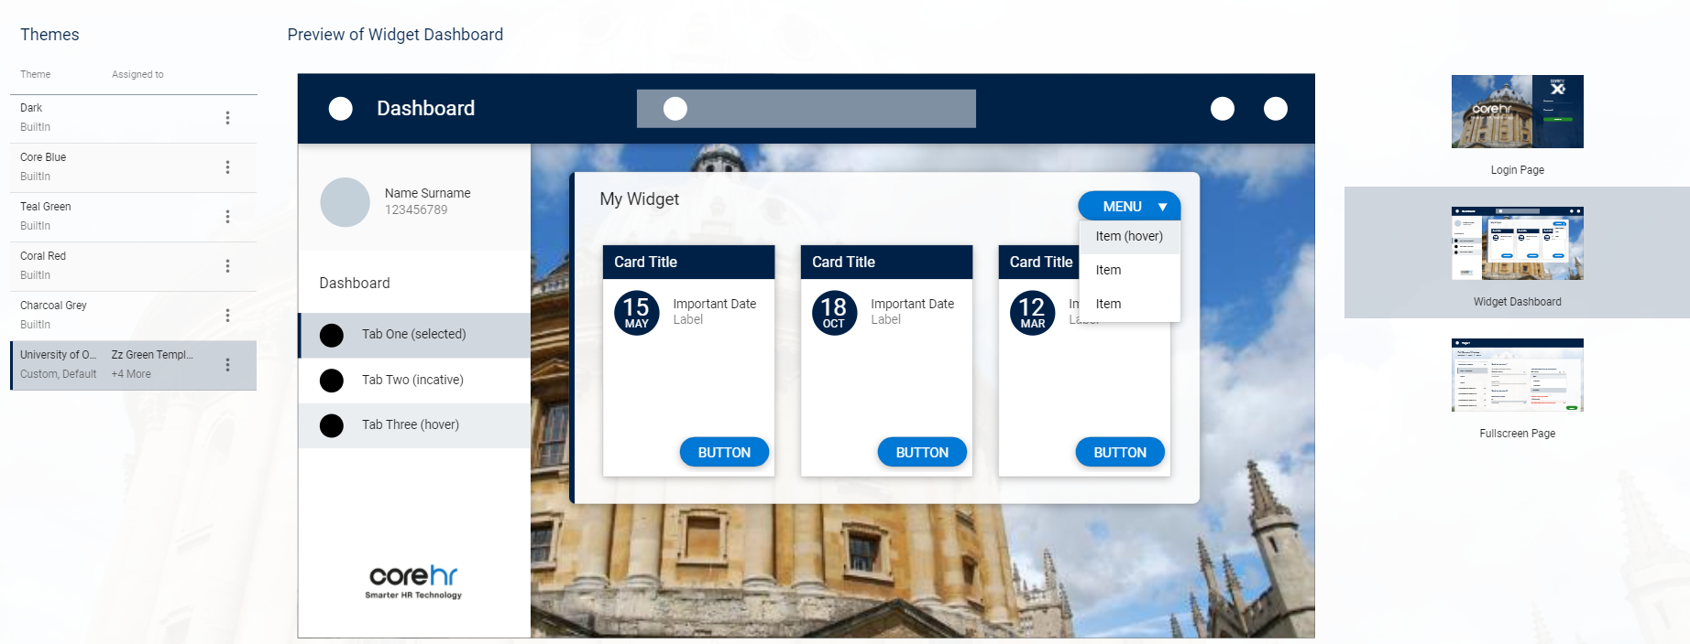

Dashboards

Viewing the current configuration

Core|Portal > Quick Jump > Dashboard Configuration

- Select a dashboard from the drop-down list.  The top half of the screen (A) shows the tabs included in the dashboard, the lower half (B) shows the widgets on each tab. | 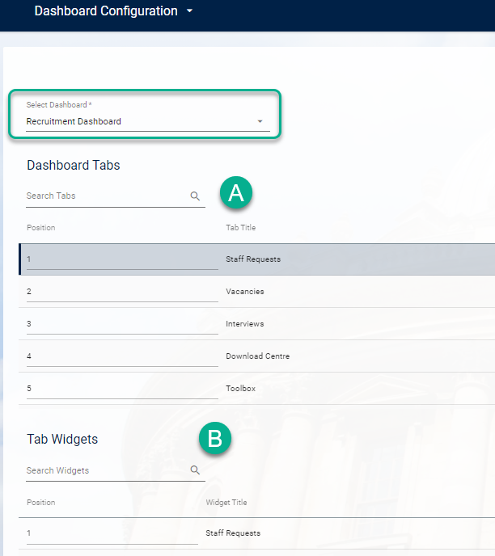
- Click on a tab title to display the widgets on that tab. | 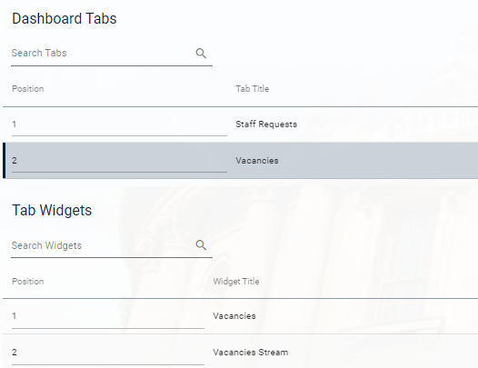

Adding a new tab
- Click on 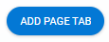.  The ‘Edit tab’ window opens. | 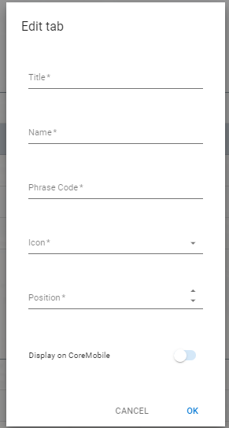

 | NB: Some widgets are only available in the Classic UI (we use the modern UI). This is indicated in the Availability column. We don’t currently use any widgets that are only available in the CUI.

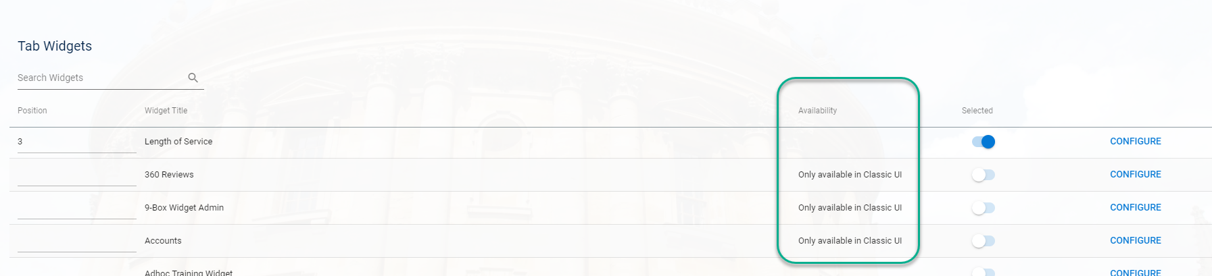

  - Enter/select as required:
Field Name | Description
Title* | Enter as required (this is the display name as it will appear on the dashboard)
Name* | Enter the same as the Title but with no spaces
Phrase Code* | Enter the same as the Title but with no spaces
Icon* | Select an appropriate icon from the drop down list
Height
Position* | Select as appropriate depending on the number of tabs you are adding to the dashboard.
Display on CoreMobile | No (TBC)

  - SAVE.

Editing an existing tab
 | NB: this will only edit the appearance of the tab. E.g. the title or the icon displayed.

  - Click on the ellipses and choose Edit Tab.

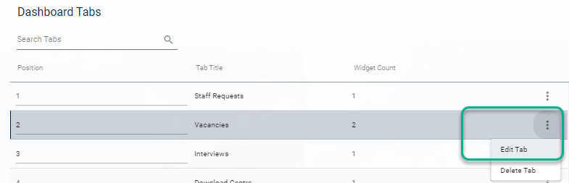

- In the Edit Tab window, update as required.  - Click OK. A confirmation message will appear  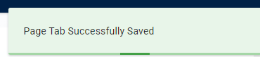 | 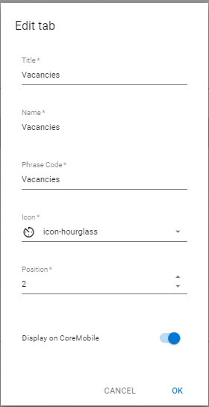

Adding or removing a widget

  - Click on the Tab title to show the available widgets. (Widgets already included will be shown at the top of the list).

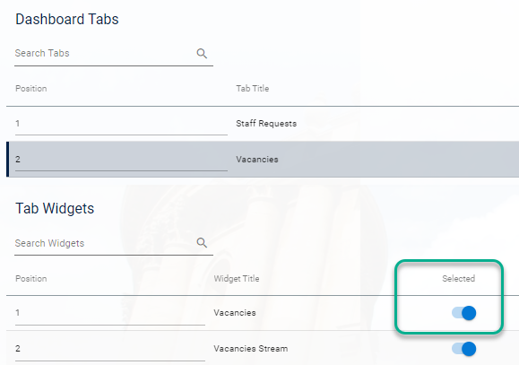

  - To add a widget, slide the toggle button to the right 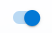

  - To remove a widget, slide the toggle button to the left 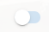

Portal Parameters (Admin settings)

Core|Portal > Administrator Dashboard > Admin Settings

- Enter all or part of the parameter text in the Keyword Search box.
Choose ‘Search Whole Phrase’ or ‘Search Individual Word’ and click on the magnifying glass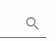.

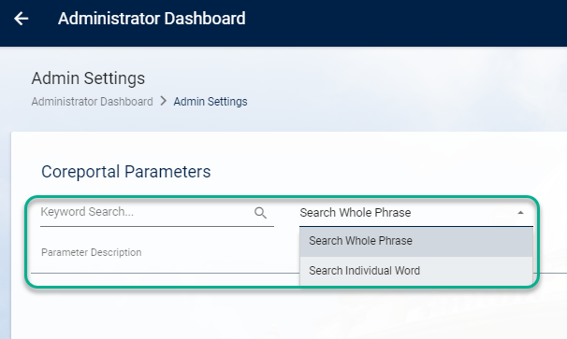

 | NB: Start with the minimum amount of text to search under. If necessary increase the text entered in the Keyword Search to narrow down the results.

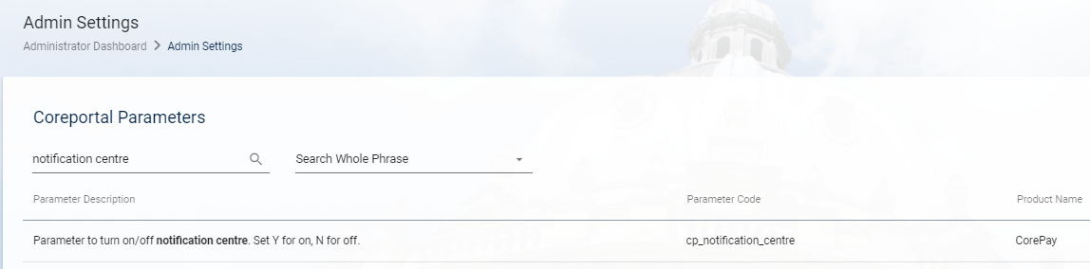

- Once the required parameter is displayed click EDIT.

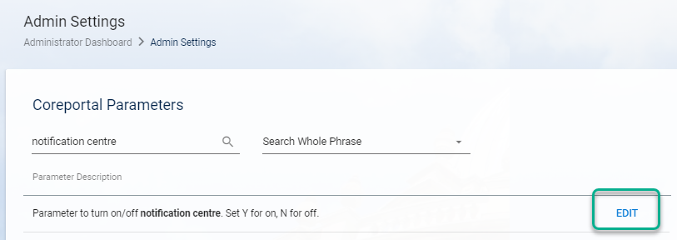

- In the pop-up window enter the new value for the parameter and click OK.

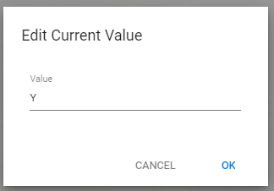

 | NB: The text can be by Y, N, actual text or reference data. All entries should be in CAPITALS.

Interview Panel settings

Core|Portal > Recruitment > Toolbox > Panel Member Types

- In the Panel Member Types screen ensure all are ticked to Active.

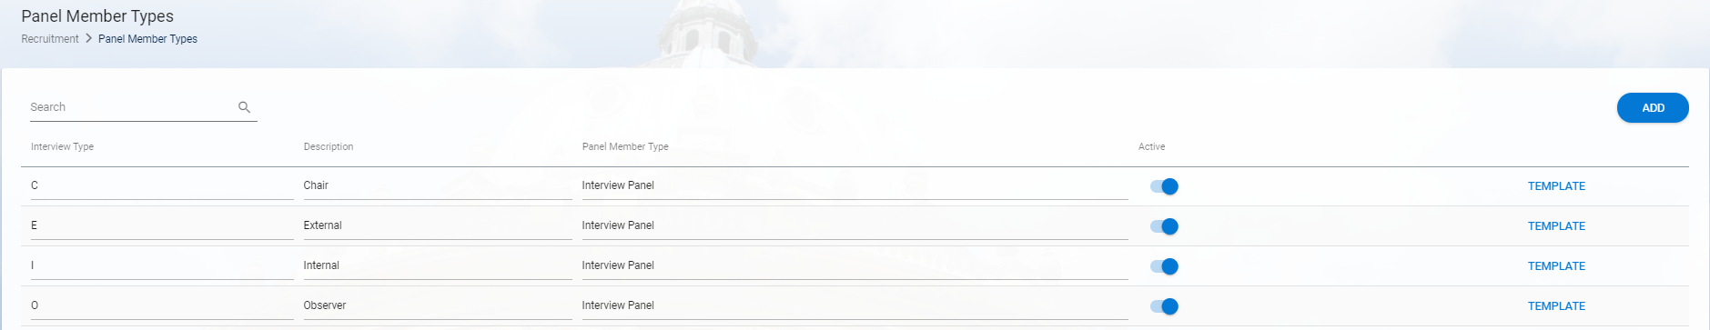

- Update if required and SAVE

- Click on the breadcrumb trail to exit.

HR Admin (widget) Settings

Core|Portal>People Management>Data Centre>HR Admin Setup Settings

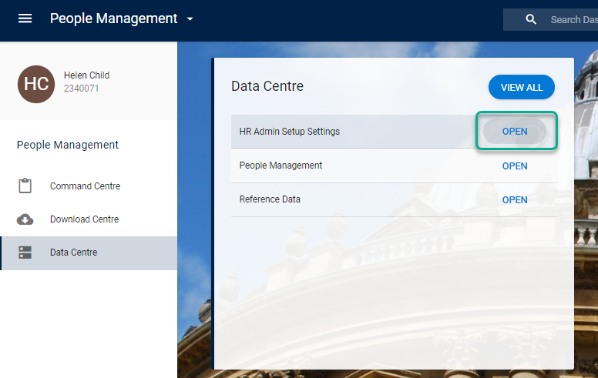

- Select HR Admin Field Options. In Display Options choose Create Person Wizard

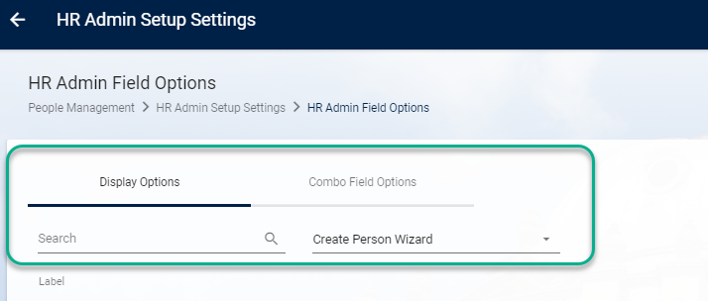

- The current setting is shown under ‘Field Options’. To update, click on EDIT.

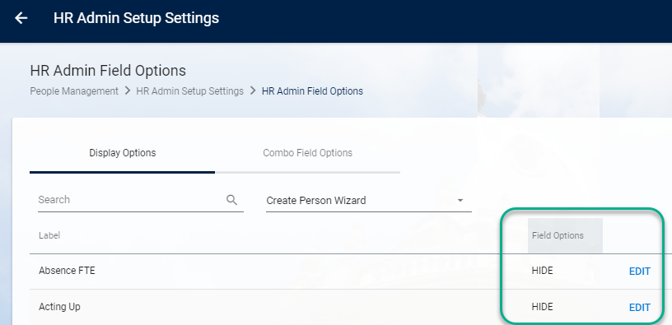

- In the Field Options window select the setting from the drop-down list. | 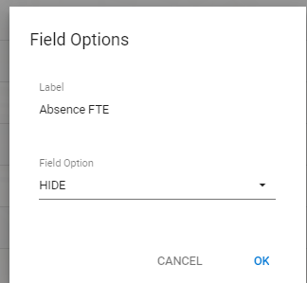

Language Pack
This can be used to change text across the Portal. Some fields are marked 'not in use' as they cannot be hidden. Not all field labels or items are available for editing in the language pack but many are. Some of the items will have multiple instances and it's not always easy to locate the exact instance you need. In that case one option is to add a number at the end of each instance 1,2,3 …… then navigate to the screen in which the text you want to change appears to see which number suffix is displayed.

Core|Portal > Administrator Dashboard > Language Pack

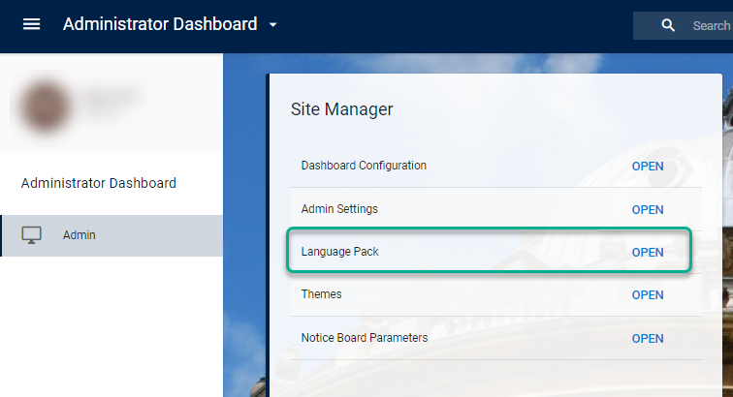

- Enter your phrase or text in the search box and click on the magnifying glass.

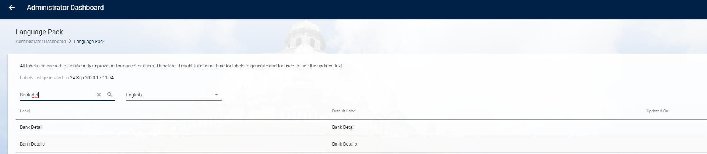

 | Note: The ‘Default Label’ is the system setting and cannot be changed.

- To edit a Label, click in the relevant field and replace the existing text then press Tab or click outside the box.

 | NB: Labels are cached so you may need to clear your browser cache, log out and log back in to see the changes.

 | NB: Agreed format for fields marked not in use. Change label to Not in use followed by the default field name in brackets up to a maximum of 20 characters within the brackets. Otherwise abbreviate the text in brackets to something that identifies the original label.  For example: Not in use (Internal Application Form) becomes Not in use (Internal App Form).

Template configuration

HR Administration Settings>Data Centre>Template Configuration Centre

Document templates

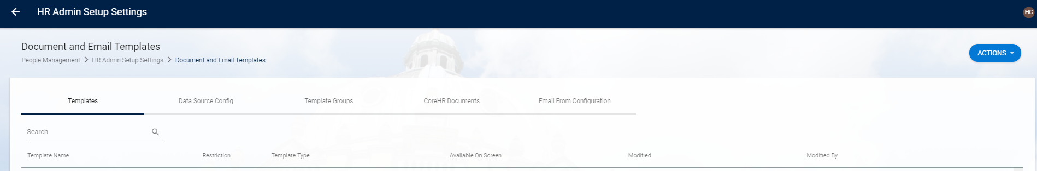

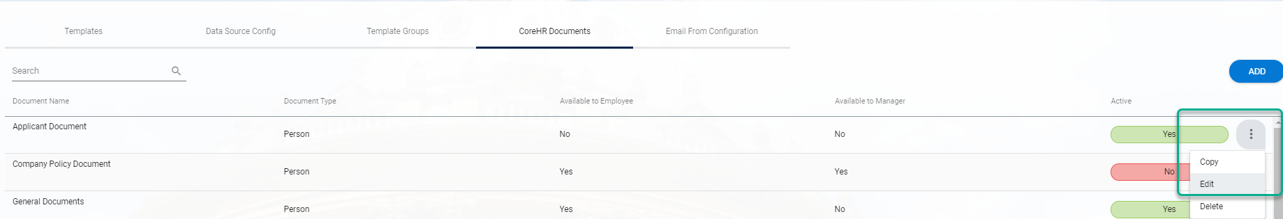

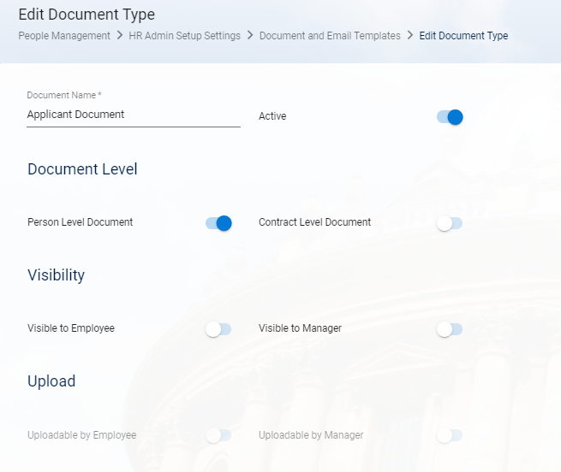

  - In the Edit Document Type window click in the Document Name field and edit as required.

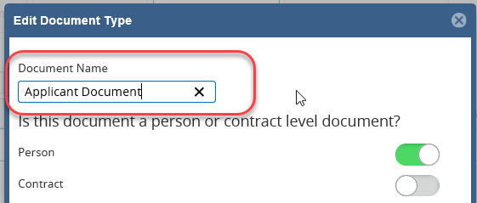

  - SAVE
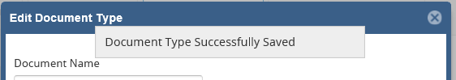
  - Click on the breadcrumb trail to exit back to the Template Configuration Centre

For full details of the current document and email templates refer to the Document template tracker.
For full details on creating and editing document and email templates refer to HOW TO Maintain Document and email templates in the portal.

Document types

  - The following Document Types should not be active:-

ACTDOC & ###### –
Health and Safety Documents
P60 Documents
Company Policy Document
Shorter Working Year
Total Reward Statement

  - Click on the ellipses (…) against the file name and choose Edit.

  - In the Edit Document Type window untick the 'Active' box.

  - SAVE

  - Click on the breadcrumb trail to exit back to the Template Configuration Centre

Reference data

Event Management

CorePortal>HR Administration Dashboard>Reference Data>Event Type

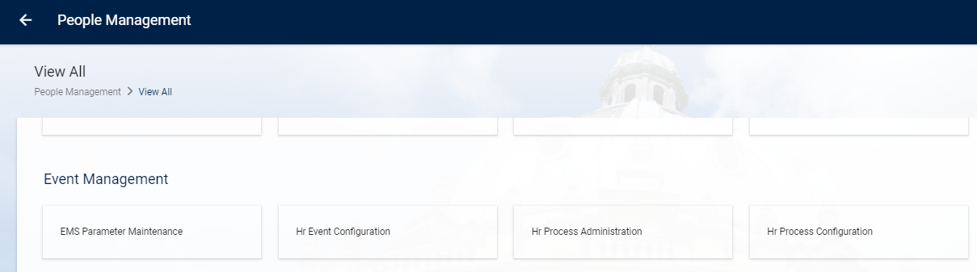
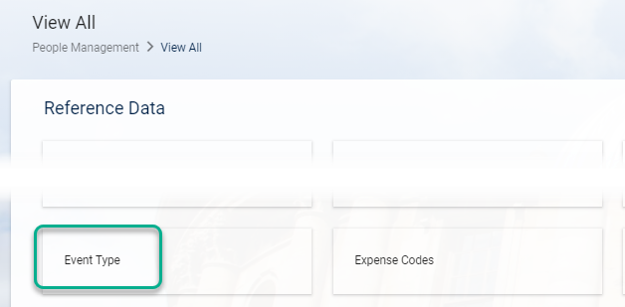

  - Creating a new event type

- Click on 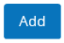

- A new line will appear at the top of the list

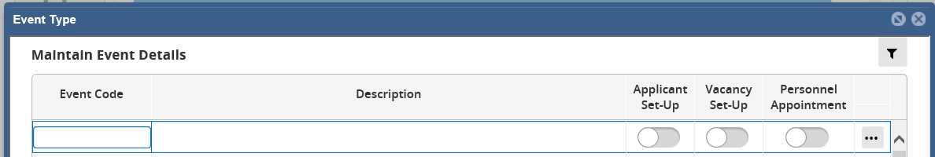

- Enter the Event Code and Description

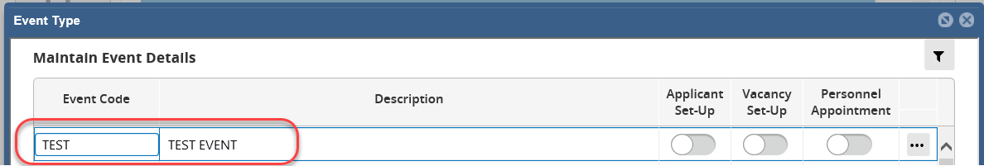

- Use the toggle buttons to set which screen(s) the event should be available on.

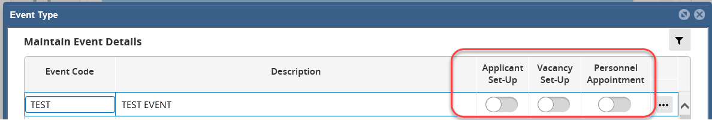

- SAVE and X to Exit

  - Editing an existing event type

- In the Event Type window scroll down to find the code(s) to edit.

- Click in any column header to sort by that column if required.

- To edit the Description, click in the description field and update as required.

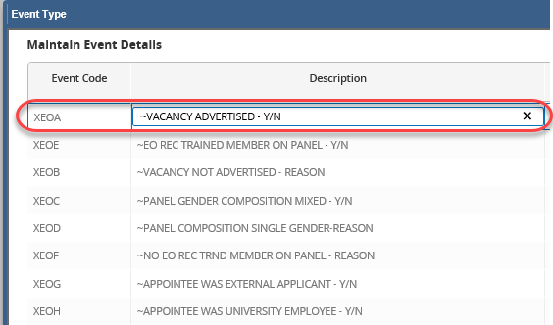

- Click on the ellipses (…) to delete or duplicate an event.

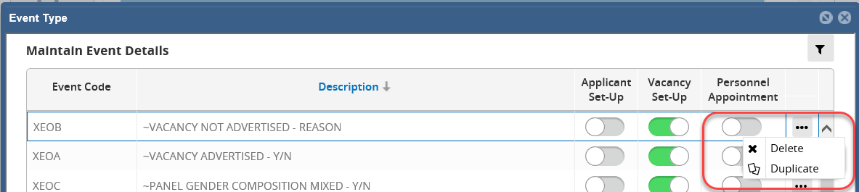

- Click on the toggle buttons to change the screen the events can be created from

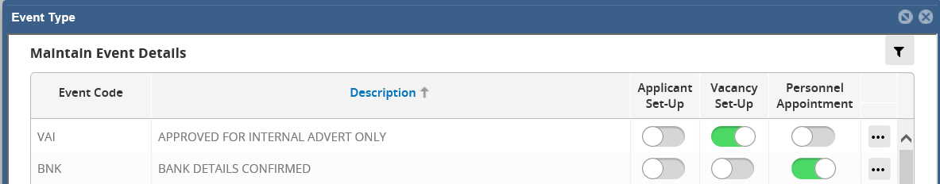

- SAVE and X to Exit.

Online application form profile and templates

Core|Portal > Recruitment Dashboard > Toolbox > Recruitment Admin

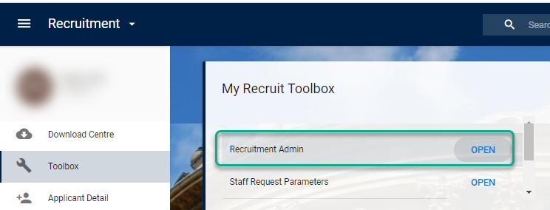

- Select Company = UNIVERSITY OF OXFORD and Form Type = E-Recruitment Form

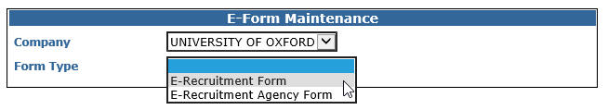
- In the E-Form maintenance screen click on 'Search Appointments Version 4'.

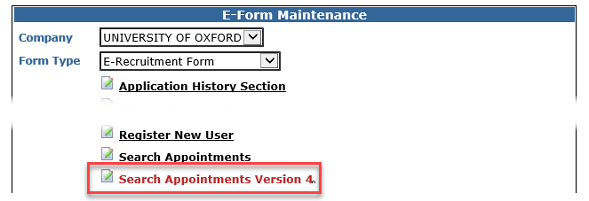

- Scroll to the bottom section labelled 'Search Appointments Version 4 Results'

- Untick the following:

- Include LinkedIn  - Include Facebook  - Include Email  - Include Twitter | 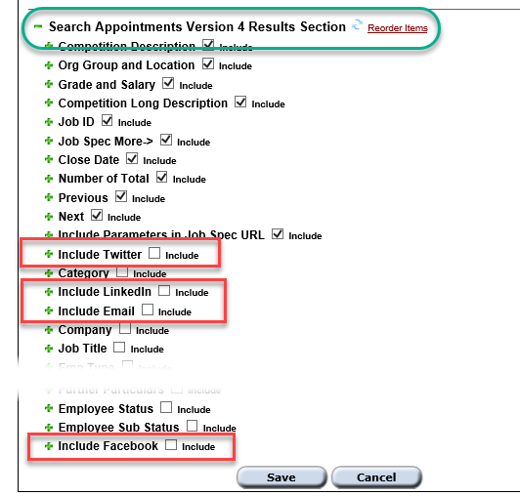

- SAVE

Related Documents

How to configure the back office…..

- Add the following

Themes

